1. **Creating Database**

Use gridfs

1. **Creating Collection :**

* **Patient:**

db.createCollection("patient")

Inserting data into collection Patient as shown in below screenshot:

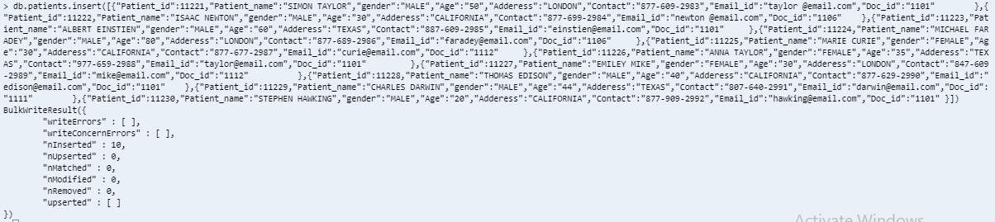

* **ctFiles.files**

db.createCollection("ctFiles.files ")

* **ctFiles.chunks**

db.createCollection("ctFiles.chunks ")

1. **File upload using Nodejs-gridfs-angular2 – Setup**

* git clone https://github.com/rahil471/fileupload-nodejs-gridfs-angular2.git
* cd fileupload-nodejs-gridfs-angular2/
* npm install
* In new terminal, started node server

node app.js

the node server started on port 3002

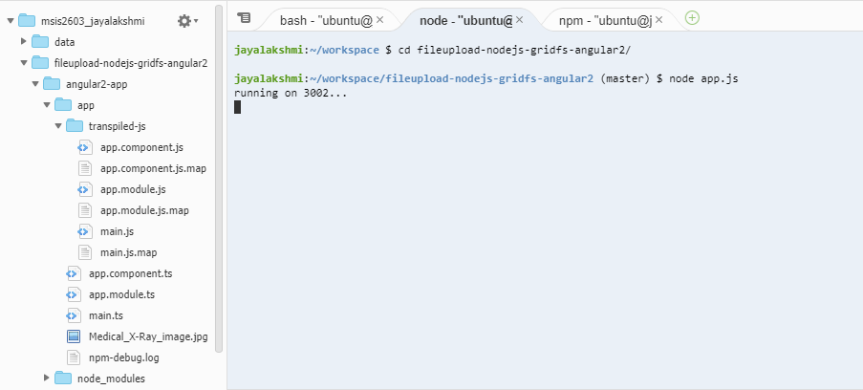

* Connection to the application:

cd angular2-app

npm start

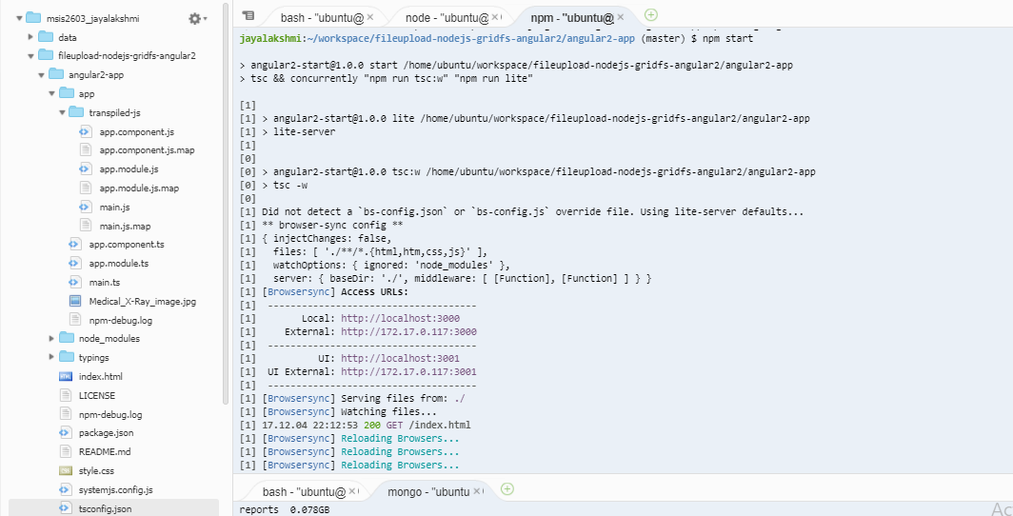

* angular2 app will be running on port 3000 and will open in browser as shown below. The images to be stored is uploaded

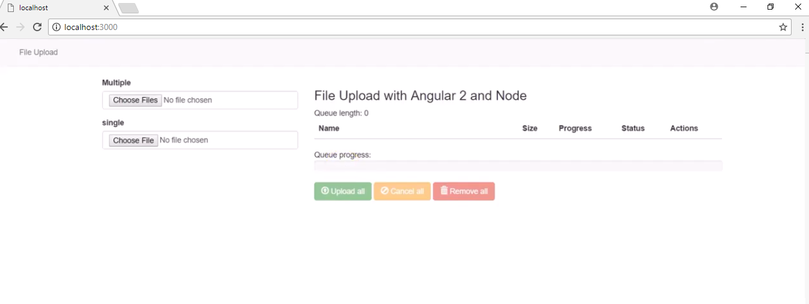

**Data retrieval QUERIES:**

* + 1. **To retrieve patient details:**

Db.patients.find({“Patient_id”:11221}).pretty()

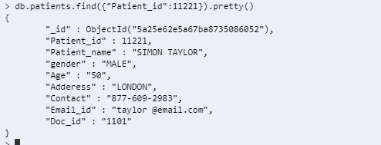

* + 1. **To retrieve and view the images in mongo:**
* **The metadata of the uploaded files are viewed as follows:**

Use gridfs

Db.ctFiles.files.find()

Meta data of uploaded files from collection ctFiles

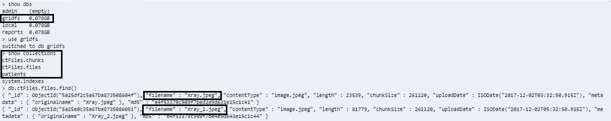

* Chunks of the uploaded files are viewed as:

Db.ctFiles.chunks.find()

Information about the chunks and the file id:

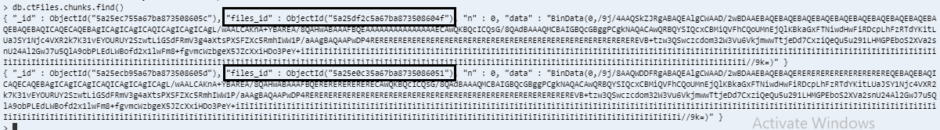

* + 1. **To retrieve and view the images in application**

By Typing the below host address the image is retrieved from Mongo DB into the application:

localhost3002/files/Xray.jpeg

Screenshot of the retrieved image from mongo

